**SHRIMATI INDIRA GANDHI COLLEGE**

**TRICHY**

DEPARTMENT OF PHYSICS

NAAN MUDHALVAN PROJECT REPORT

**Project partner: Smart internz**

**Project by: data literacy with Tableau**

Class: III B.SC (PHYSICS)

Team ID: NM2023TMID04695

**A DATA-DRIVEN EXPLORATION OF APPLE’S IPHONE IMPACT IN INDIA**

**INTRODUCTION**

**OVERVIEW:**

* IPhone is a line of smartphones produced by Apple Inc. that use Apple's own iOS mobile operating system. The first-generation iPhone was announced by then-Apple CEO Steve Jobs on January 9, 2007. Since then, Apple has annually released new iPhone models and iOS updates. As of November 1, 2018, more than 2.2 billion iPhones had been sold. As of 2022, the iPhone accounts for 15.6% of global smartphone market share.

**PURPOSE:**

* IPhones are primarily used for making calls, sending texts, and using messaging apps to communicate with friends, family, and colleagues.
* Many users rely on iPhones for work-related tasks, such as emails, document editing, and project management, thanks to the iOS ecosystem and productivity apps.

**PROBLEMS DEFINATION AND DESING THINKING**

**EMPATHY MAP:**

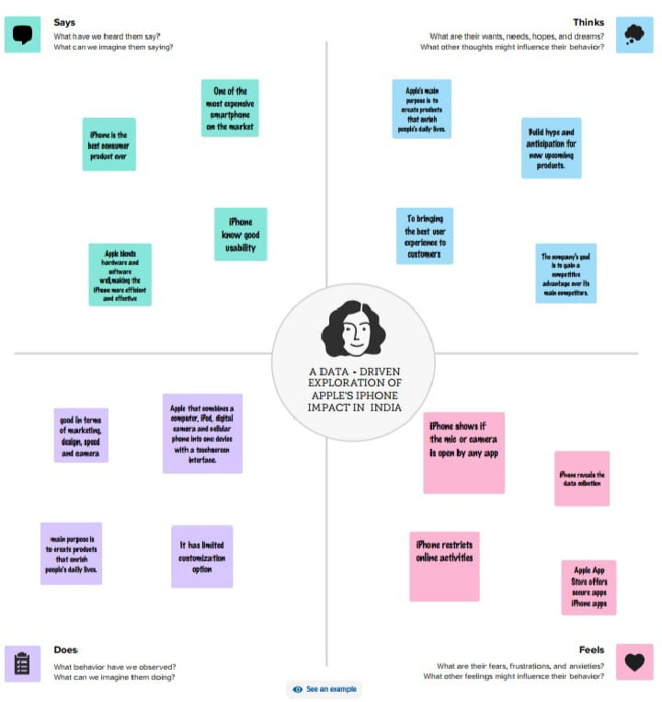

**BRAINSTROMING MAP:**

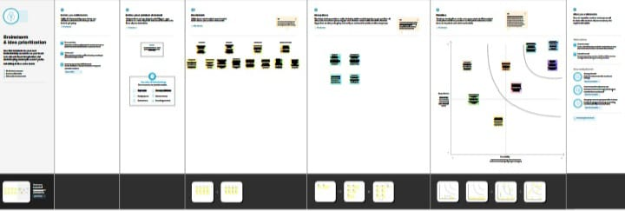

**RESULT:**

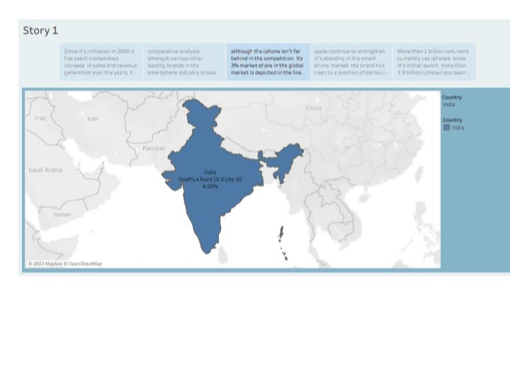

In this project we conclude that the Apple’s IPhone Impact in India**.**

**ADVANTAGE:**

* IPhones are known for their build quality, which appeals to consumers looking for a premium device.
* IPhones offer seamless integration with other Apple devices, such as Macs and iPads.
* Apple provides timely software updates, including security patches and new features.
* The Apple App Store offers a wide range of high-quality apps and services.
* IPhones tend to retain their value well, making them a good long-term investment.

**DISADVANTAGE:**

* IPhones are relatively expensive compared to many Android alternatives, limiting access for budget-conscious consumers.
* Limited Customization: iOS offers less customization compared to Android, which may not appeal to users who prefer personalization.
* Some Apple services and features may not be as fully developed in India compared to regions like the United States.
* Android phones from various manufacturers dominate the Indian market, offering a wider range of options.
* Proprietary Ecosystem: Being tied to the Apple ecosystem can be limiting if you use non-Apple devices or services.

CONCLUSION:

* Apple and the IPhone is a great example of a corporation making what the consumer wants in a global market. With limited companies competing, competition for the best phone on the market is at an all-time high. With the iPhone you get better quality and better security when dealing with your personal information. Innovation and technological advancements have keep the iPhone and Apple ahead of its competitors in this tight notch market. With the iPhone being so popular and in high demand, estimated shortages are suspected.

**FUTURE SCOPE:**

* The future scope of Apple iPhones in India appears promising. Apple has been increasing its focus on the Indian market in recent years, aiming to tap into the country's growing middle-class population and increasing smartphone adoption.

**APPENDIX**

**SOURCE CODE:**

https://public.tableau.com/app/profile/nivitha.r